

***STUDENT NAME:*** KINTU DECLAN TREVOR.

***STUDENT ID:*** 646620.

***COURSE:*** APT4900.

***COURSE INSTRUCTOR:*** PROF. OKANDA.

***FINAL PROJECT REPORT: QwikTings.***

**DECLARATION.**

*“I certify that the material contained in this dissertation is my own work and does not contain unreferenced or unacknowledged material. I also warrant that the above statement applies to the implementation of the project and all associated documentation. Regarding the electronically submitted version of this submitted work, I consent to this being stored electronically and copied for assessment purposes, including the Department’s use of plagiarism detection systems in order to check the integrity of assessed work. I agree to my dissertation being placed in the public domain, with my name explicitly included as the author of the work.”*

Date:                     Signed:

**Contents**

[**DECLARATION.**    2](https://docs.google.com/document/d/1osjuAWKlpnzYS9EUaoaxZPl7YGdRVFjVABDzKVbeTtE/edit#heading=h.gjdgxs)

[**ABSTRACT.**    4](https://docs.google.com/document/d/1osjuAWKlpnzYS9EUaoaxZPl7YGdRVFjVABDzKVbeTtE/edit#heading=h.30j0zll)

[**1)**    **INTRODUCTION.**    5](https://docs.google.com/document/d/1osjuAWKlpnzYS9EUaoaxZPl7YGdRVFjVABDzKVbeTtE/edit#heading=h.1fob9te)

[**Sections of the Report.**    8](https://docs.google.com/document/d/1osjuAWKlpnzYS9EUaoaxZPl7YGdRVFjVABDzKVbeTtE/edit#heading=h.3znysh7)

[**2)**    **BACKGROUND.**    9](https://docs.google.com/document/d/1osjuAWKlpnzYS9EUaoaxZPl7YGdRVFjVABDzKVbeTtE/edit#heading=h.2et92p0)

[**a)**    **Market Research.**    9](https://docs.google.com/document/d/1osjuAWKlpnzYS9EUaoaxZPl7YGdRVFjVABDzKVbeTtE/edit#heading=h.tyjcwt)

[**b)**    **Challenges.**    12](https://docs.google.com/document/d/1osjuAWKlpnzYS9EUaoaxZPl7YGdRVFjVABDzKVbeTtE/edit#heading=h.3dy6vkm)

[**c)**    **Conclusion.**    12](https://docs.google.com/document/d/1osjuAWKlpnzYS9EUaoaxZPl7YGdRVFjVABDzKVbeTtE/edit#heading=h.1t3h5sf)

[**3)**    **PROPOSED SYSTEM.**    13](https://docs.google.com/document/d/1osjuAWKlpnzYS9EUaoaxZPl7YGdRVFjVABDzKVbeTtE/edit#heading=h.4d34og8)

[**a)**    **Aims and Objectives.**    13](https://docs.google.com/document/d/1osjuAWKlpnzYS9EUaoaxZPl7YGdRVFjVABDzKVbeTtE/edit#heading=h.2s8eyo1)

[**b)**    **Methodology.**    13](https://docs.google.com/document/d/1osjuAWKlpnzYS9EUaoaxZPl7YGdRVFjVABDzKVbeTtE/edit#heading=h.17dp8vu)

[**c)**    **Work plan.**    14](https://docs.google.com/document/d/1osjuAWKlpnzYS9EUaoaxZPl7YGdRVFjVABDzKVbeTtE/edit#heading=h.3rdcrjn)

[**d)**    **Requirements.**    15](https://docs.google.com/document/d/1osjuAWKlpnzYS9EUaoaxZPl7YGdRVFjVABDzKVbeTtE/edit#heading=h.26in1rg)

[**e)**    **Conclusion.**    15](https://docs.google.com/document/d/1osjuAWKlpnzYS9EUaoaxZPl7YGdRVFjVABDzKVbeTtE/edit#heading=h.lnxbz9)

[**4)**    **DESIGN.**    16](https://docs.google.com/document/d/1osjuAWKlpnzYS9EUaoaxZPl7YGdRVFjVABDzKVbeTtE/edit#heading=h.35nkun2)

[**a)**    **Architecture Diagram.**    16](https://docs.google.com/document/d/1osjuAWKlpnzYS9EUaoaxZPl7YGdRVFjVABDzKVbeTtE/edit#heading=h.1ksv4uv)

[**b)**    **Flow Chart.**    17](https://docs.google.com/document/d/1osjuAWKlpnzYS9EUaoaxZPl7YGdRVFjVABDzKVbeTtE/edit#heading=h.44sinio)

[**c)**    **Use Cases.**    18](https://docs.google.com/document/d/1osjuAWKlpnzYS9EUaoaxZPl7YGdRVFjVABDzKVbeTtE/edit#heading=h.2jxsxqh)

[**d)**    **Data Flow Diagram.**    19](https://docs.google.com/document/d/1osjuAWKlpnzYS9EUaoaxZPl7YGdRVFjVABDzKVbeTtE/edit#heading=h.z337ya)

[**e)**    **Entity Relationship Diagram.**    20](https://docs.google.com/document/d/1osjuAWKlpnzYS9EUaoaxZPl7YGdRVFjVABDzKVbeTtE/edit#heading=h.3j2qqm3)

[**f)**    **Sequence Diagram.**    21](https://docs.google.com/document/d/1osjuAWKlpnzYS9EUaoaxZPl7YGdRVFjVABDzKVbeTtE/edit#heading=h.1y810tw)

[**g)**    **Conclusion.**    22](https://docs.google.com/document/d/1osjuAWKlpnzYS9EUaoaxZPl7YGdRVFjVABDzKVbeTtE/edit#heading=h.4i7ojhp)

[**5)**    **IMPLEMENTATION & DEVELOPMENT.**    23](https://docs.google.com/document/d/1osjuAWKlpnzYS9EUaoaxZPl7YGdRVFjVABDzKVbeTtE/edit#heading=h.2xcytpi)

[**a)**    **Administrator.**    23](https://docs.google.com/document/d/1osjuAWKlpnzYS9EUaoaxZPl7YGdRVFjVABDzKVbeTtE/edit#heading=h.1ci93xb)

[**c)**    **Conclusion.**    42](https://docs.google.com/document/d/1osjuAWKlpnzYS9EUaoaxZPl7YGdRVFjVABDzKVbeTtE/edit#heading=h.3whwml4)

[**6)**    **EVALUATION.**    43](https://docs.google.com/document/d/1osjuAWKlpnzYS9EUaoaxZPl7YGdRVFjVABDzKVbeTtE/edit#heading=h.2bn6wsx)

[**a)**    **Types of Tests.**    43](https://docs.google.com/document/d/1osjuAWKlpnzYS9EUaoaxZPl7YGdRVFjVABDzKVbeTtE/edit#heading=h.qsh70q)

[**b)**    **Challenges.**    46](https://docs.google.com/document/d/1osjuAWKlpnzYS9EUaoaxZPl7YGdRVFjVABDzKVbeTtE/edit#heading=h.1pxezwc)

[**c)**    **Conclusion.**    46](https://docs.google.com/document/d/1osjuAWKlpnzYS9EUaoaxZPl7YGdRVFjVABDzKVbeTtE/edit#heading=h.49x2ik5)

[**7)**    **CONCLUSION AND FUTURE WORK.**    47](https://docs.google.com/document/d/1osjuAWKlpnzYS9EUaoaxZPl7YGdRVFjVABDzKVbeTtE/edit#heading=h.2p2csry)

[**a)**    **Future Work.**    47](https://docs.google.com/document/d/1osjuAWKlpnzYS9EUaoaxZPl7YGdRVFjVABDzKVbeTtE/edit#heading=h.147n2zr)

[**References**    48](https://docs.google.com/document/d/1osjuAWKlpnzYS9EUaoaxZPl7YGdRVFjVABDzKVbeTtE/edit#heading=h.3o7alnk)

[**APPENDIX I: PROPOSAL LETTER.**    49](https://docs.google.com/document/d/1osjuAWKlpnzYS9EUaoaxZPl7YGdRVFjVABDzKVbeTtE/edit#heading=h.23ckvvd)

[**ABSTRACT.**    49](https://docs.google.com/document/d/1osjuAWKlpnzYS9EUaoaxZPl7YGdRVFjVABDzKVbeTtE/edit#heading=h.ihv636)

[**INTRODUCTION.**    49](https://docs.google.com/document/d/1osjuAWKlpnzYS9EUaoaxZPl7YGdRVFjVABDzKVbeTtE/edit#heading=h.32hioqz)

[**BACKGROUND.**    50](https://docs.google.com/document/d/1osjuAWKlpnzYS9EUaoaxZPl7YGdRVFjVABDzKVbeTtE/edit#heading=h.1hmsyys)

[**PROPOSED PROJECT.**    50](https://docs.google.com/document/d/1osjuAWKlpnzYS9EUaoaxZPl7YGdRVFjVABDzKVbeTtE/edit#heading=h.2grqrue)

[**PROGRAM OF WORK.**    51](https://docs.google.com/document/d/1osjuAWKlpnzYS9EUaoaxZPl7YGdRVFjVABDzKVbeTtE/edit#heading=h.3fwokq0)

[**GANTT CHART.**    51](https://docs.google.com/document/d/1osjuAWKlpnzYS9EUaoaxZPl7YGdRVFjVABDzKVbeTtE/edit#heading=h.4f1mdlm)

[**RESOURCES REQUIRED.**    52](https://docs.google.com/document/d/1osjuAWKlpnzYS9EUaoaxZPl7YGdRVFjVABDzKVbeTtE/edit#heading=h.2u6wntf)

[**APPENDIX II: QwikTings API.**    53](https://docs.google.com/document/d/1osjuAWKlpnzYS9EUaoaxZPl7YGdRVFjVABDzKVbeTtE/edit#heading=h.19c6y18)

**ABSTRACT.**

The project was to design and develop an application which would enable the clients of Advance Innovations to access their QwikShop stores via android mobile devices and have them delivered to a location of their preference. QwikTings was thus developed to achieve just that. The solution provides a web based application where clients can update and view their orders information and customer's data, give accurate locations to where their deliveries go and see the progress of their deliveries in real time.

1. **INTRODUCTION.**

Advance Innovations is based in Kampala, Uganda with a presence in Nairobi, Kenya. They provide East Africa with professional web solutions. Their main solution is the QwikTings, this is an ecommerce software solution which has everything you need to setup an online web store and sell products.

With the recent rise of smartphones and the increasing amount of application which can run on them, making it easier for user to access the internet on the move. This leaves Advance Innovations with a problem: their clients are looking for ways to access their QwikShop stores on the move. Advance Innovations then offered to solve this problem by developing a mobile application which will allow their QwikShop clients to access their stores on the move via their android smartphones and have the items they purchase safely delivered to locations of their choices. After consulting with their clients, Advance Innovations decided to target the Android platform for their first smartphone application.

More than half a billion people across Africa now subscribe to mobile services, with the number expected to grow to 725 million by 2020. Within that five-year period, the monthly use of mobile data will also increase from 0.3 GB to 4.3 GB. Operators have recorded data traffic growth of more than 50% in 2015.

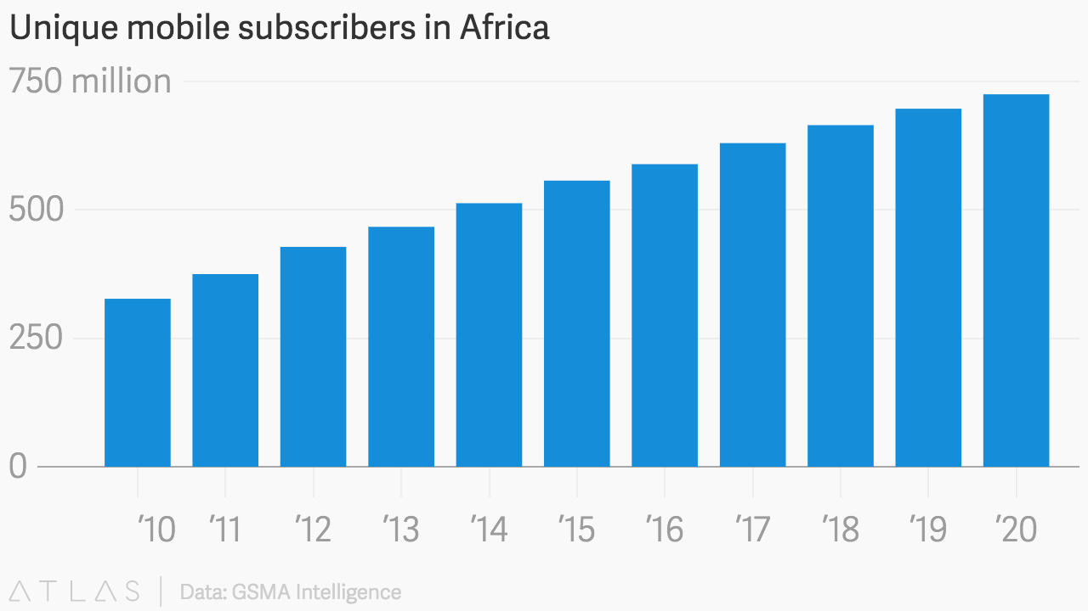

*(source:* [*https://qz.com/africa/748354/smartphone-use-has-more-than-doubled-in-africa-in-two-years/*](https://qz.com/africa/748354/smartphone-use-has-more-than-doubled-in-africa-in-two-years/)*)*

This growth in data use is occurring despite problems with affordability and costs, not to mention lack of digital literacy in some parts of the continent. Kenya, Egypt, Nigeria and South Africa are some of the more technologically advanced nations pushing the high usage of data. New entrants effectively utilizing the 3G technology include countries like Algeria, Cameroon and the Democratic Republic of Congo. Still, the African market lags behind other developing nations in smartphone adoption and mobile broadband use.

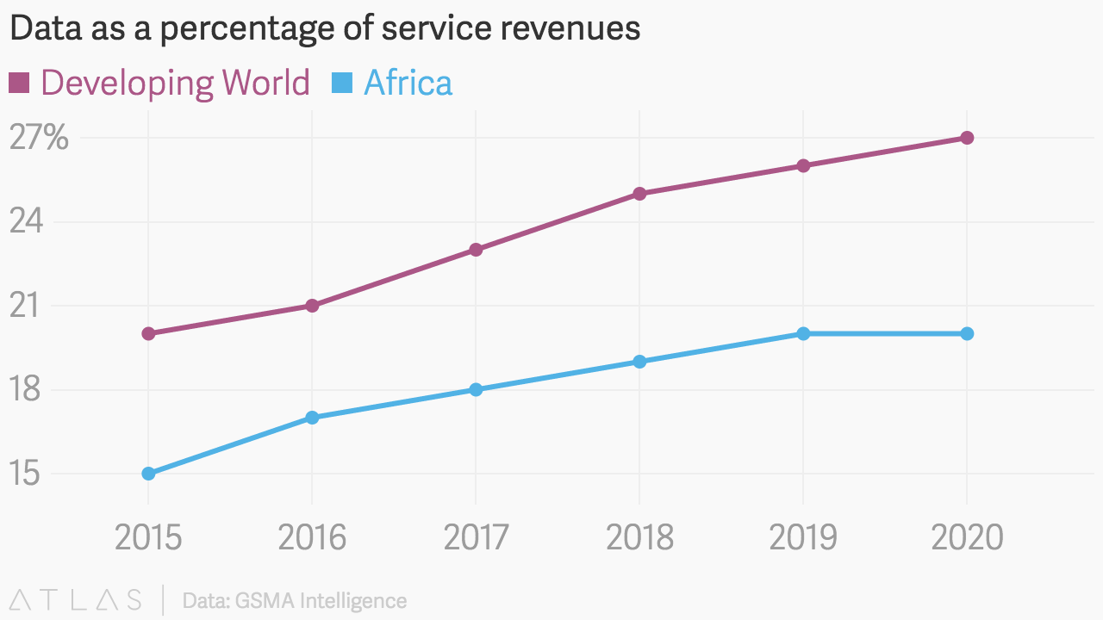

*(source:* [*https://qz.com/africa/748354/smartphone-use-has-more-than-doubled-in-africa-in-two-years/*](https://qz.com/africa/748354/smartphone-use-has-more-than-doubled-in-africa-in-two-years/)*)*

The growth of the mobile industry is also a boon for both investors and governments, the GSMA report states. The use of mobile services and technologies directly contributed to $17 billion in government taxes in 2015. In general, mobile services generated 6.7% of the continent’s GDP, totalling around $150 billion in economic value.

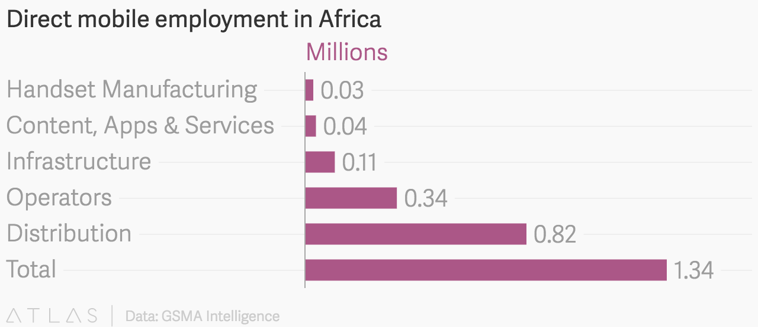

*(source:* [*https://qz.com/africa/748354/smartphone-use-has-more-than-doubled-in-africa-in-two-years/*](https://qz.com/africa/748354/smartphone-use-has-more-than-doubled-in-africa-in-two-years/)*)*

The mobile industry also directly and indirectly supported more than 3.8 million jobs. The 1.3 million direct jobs supported an additional 2.43 million indirect employment opportunities in the form of wages and public funding contributions (Dahir, 2016).

Advance Innovations have noticed the continuing trend and decided to seize the opportunity. With the increasing number of both android users and the revenue that digital markets are making, the mobile application seemed like the most logical path of action.

All Android Smartphone applications are available online on the Play Store, this is another reason why a mobile application which is targeted at the Android platform is ideal. Android has provided application developers with all the tools they need to create and distribute their application freely or commercially. The tool which is used in creating the application is the Android’s Software Development Kit (SDK) known as Android Studio. This is a fully functional development environment which has everything from advanced text editors to compiler and debug tools.

**Sections of the Report.**

* **Background** – Analysis of the mobile application market to find exciting systems currently available and the mechanisms being used in the application which would enable the aim of the project be achieved.
* **Requirements** – A detailed list of all the functional and non-functional requirements that have been proposed by Advance Innovations. A look at any assumption which have been made by any of the stakeholder which are involved with the system.
* **Design** – A discussion of the major design decisions which have been made, with a view of the system architecture and its components. A description of Android application user interface design with referring to the Android’s Human Interface Guidelines.
* **Implementation –** An overview of the application implementation with a look at the main data structures and varies algorithms used. Pseudo code for portions of code that represent interesting solutions for particular interesting problem.
* **The System in Operation –** A walkthrough of the system and what it is like to use. A description of the operations behind the user interface with screenshots to illustrate them.
* **Testing –** An overview of the testing methods which were performed to establish that the application functions correctly and the documented acceptance tests.
* **Evaluation –** A look at how well the application achieved its aims by critically analysing the test results. An overview of the user evaluation which was carried out on the user interface.
* **Conclusion –** A look back to the aims and objectives of the project, analysing whether these have been achieved. Discussing what could have been done differently if the project was to be done again, also a look at the experiences which have led to new acquire skills and knowledge.

1. **BACKGROUND.**

This chapter will analysis the mobile application market and discuss any exciting applications which perform the objectives of this project.

1. **Market Research.**

The aim of my market research is to find any mobile applications which perform similar tasks to that of the application Advance Innovations are looking for. As the proposed application is bespeaking for the clients of Advance Innovations, this document will highlight similar feature from Android applications which are currently available. I believe that it will be difficult to design an easy to use graphical user interface, so I will be looking at how exciting applications attempt to achieve this.

1. ***Amazon.***

Amazon are among the best e-commerce solutions in the world. With the owner Jeff Bezos currently holding the position for richest man alive. QwikTings is quite similar to Amazon in functionality except the application focuses on deliveries within Africa, which Amazon does not support a lot.

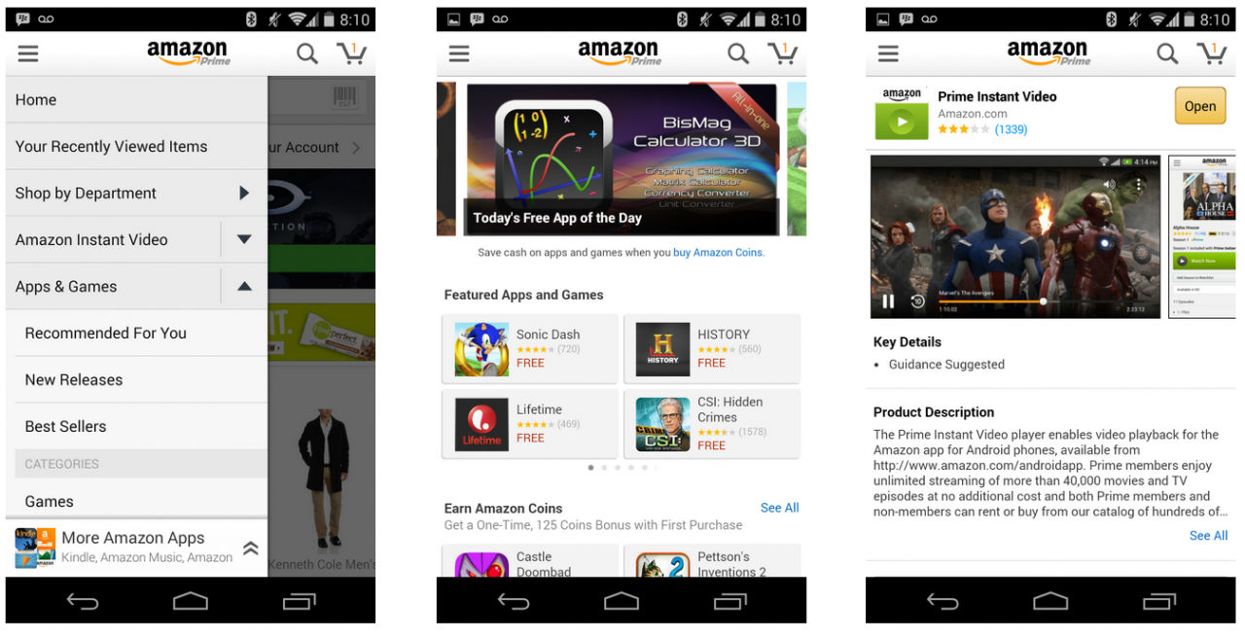

*(source:* [*https://c.slashgear.com/wp-content/uploads/2014/12/Screen-Shot-2014-12-11-at-3.13.41-PM-1280x656.png*](https://c.slashgear.com/wp-content/uploads/2014/12/Screen-Shot-2014-12-11-at-3.13.41-PM-1280x656.png)*)*

1. ***Jumia.***

Jumia can be regarded as QwikTings’ biggest competition, as they are an e-commerce application that operates within Africa. The QwikShop would have to provide services at a cheaper cost in order to complete.

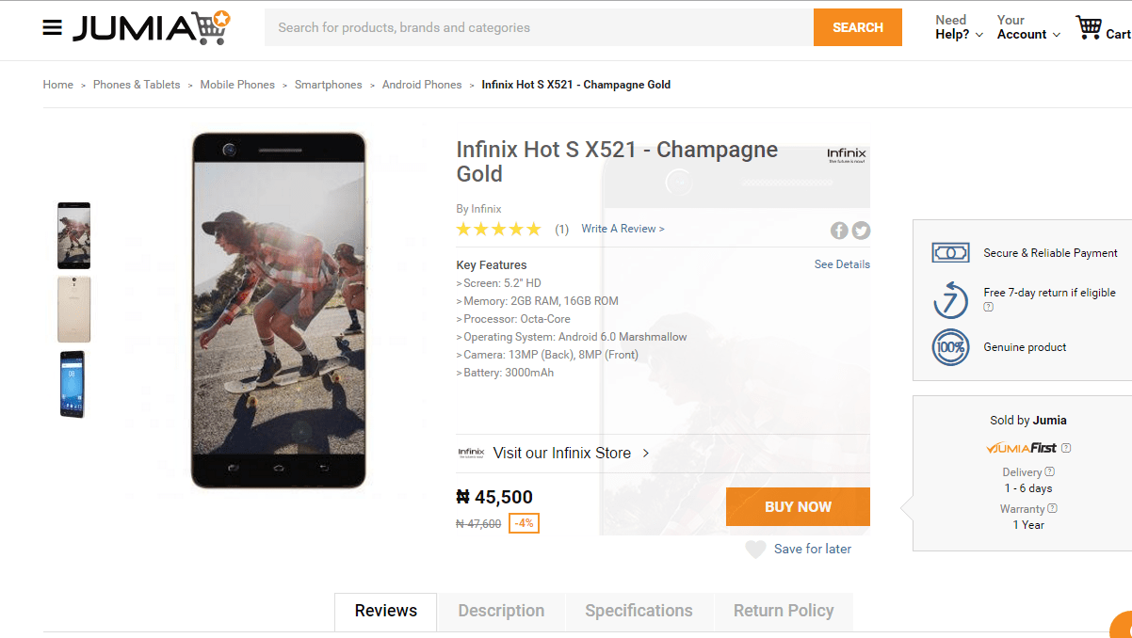

*(source:* [*https://i2.wp.com/tech-ish.com/wp-content/uploads/2016/07/Infinix-Hot-S.png?ssl=1*](https://i2.wp.com/tech-ish.com/wp-content/uploads/2016/07/Infinix-Hot-S.png?ssl=1)*)*

1. ***Alibaba.***

Alibaba is an e-commerce service that dominates the Asian market. Alibaba is also similar in its functionalities with QwikTings with the ability to deliver the goods directly to the customer after purchasing them on the Alibaba platform. But like Amazon, they too do not deliver to Africa and that is where QwikTings hopes to have the edge on its competitors.

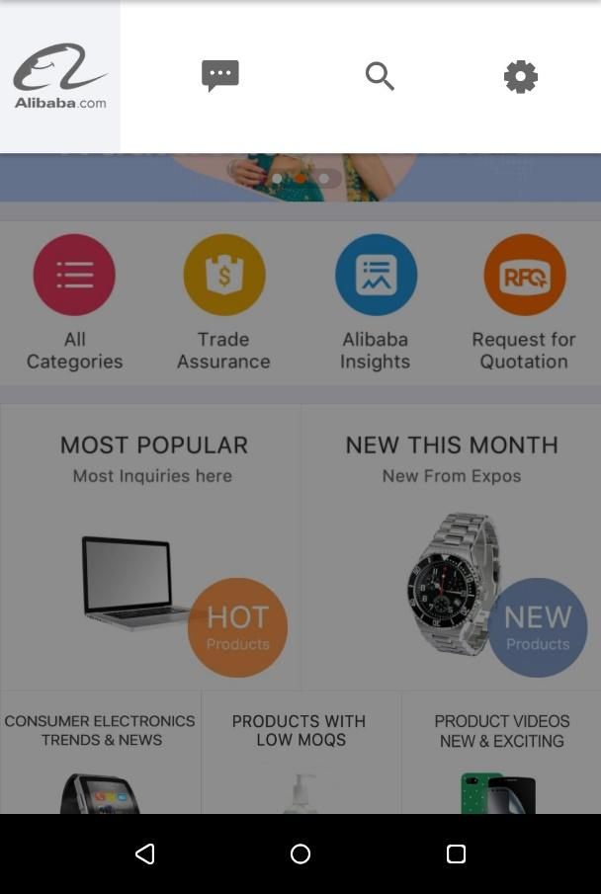

*(source:* [*https://imag.malavida.com/mvimgbig/download-fs/alibaba-app-19001-5.jpg*](https://imag.malavida.com/mvimgbig/download-fs/alibaba-app-19001-5.jpg)*)*

1. ***EBay.***

EBay is among the first e-commerce websites to be found on the internet. EBay typically deals with resales, whereas QwikTings deals with first sale. Alongside Amazon and Alibaba, EBay does not deliver to Africa, and that is the weakness QwikTings aims to exploit.

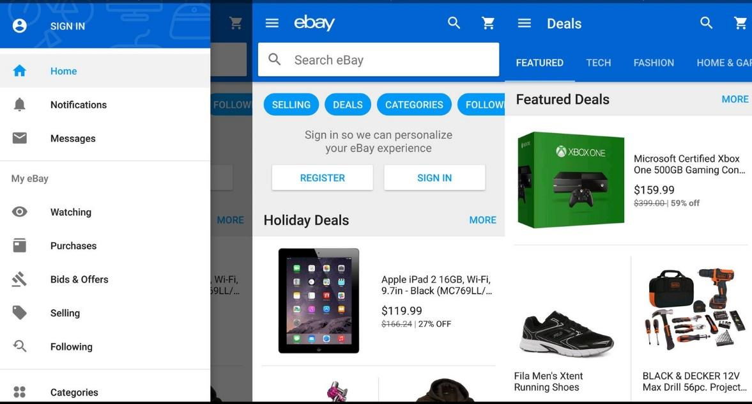

*(source:* [*https://www.androidcentral.com/sites/androidcentral.com/files/styles/xlarge/public/article_images/2016/11/deal-apps-ebay-screenshot.jpg?itok=WejscWAJ*](https://www.androidcentral.com/sites/androidcentral.com/files/styles/xlarge/public/article_images/2016/11/deal-apps-ebay-screenshot.jpg?itok=WejscWAJ)*)*

1. **Challenges.**

One of the challenges that Advance Innovations faced during this was finding a selling point that would differentiate their application from other applications. This was very difficult because all the above mentioned applications had already implicated most features, as such Advance Innovations decided to focus on the African market as a selling point.

Another challenge that Advance Innovations faced was time to implement all the aims and objectives they had set out to achieve during this project. It was a very demanding project but the time needed to complete it in was limited, as such Advance Innovations was not able to fully implement all the objectives.

Sometimes Advance Innovations would find myself under-skilled during the development of this project. As such Advance Innovations was forced to learn along the way and implement the solutions into the project.

1. **Conclusion.**

In this chapter we have reviewed my market research, the already in place solutions and explained why QwikTings has an advantage on the competition. We also talked about what the competitors are doing better than QwikTings and areas that would need improvement with time.

1. **PROPOSED SYSTEM.**

QwikTings is a mobile e-commerce application that allows the user to login and access the QwikShop online and make purchases. After which the customer can select a location to have their products delivered to and monitor the delivery process in real time.

1. **Aims and Objectives.**

* Ability for user to Login, Register and Logout of application.
* Ability for user to select item and add to cart while logged in application.
* Ability for user to checkout cart and pay for goods while logged in application.
* Ability for user to view self and item on Map while logged in application.

1. **Methodology.**

The methodology used during the development of this application is known as the Waterfall Method. In “***The Waterfall***” approach, the whole process of *software development* is divided into separate phases. The outcome of one phase acts as the input for the next phase sequentially. This means that any phase in the development process begins only if the previous phase is complete. The waterfall model is a sequential design process in which progress is seen as flowing steadily downwards (like a waterfall) through the phases of  ***Conception, Initiation, Analysis, Design, Construction, Testing, Production/Implementation and Maintenance*** (Sharma, 2016)***.***

* **Requirements:**The first phase involves understanding what need to be design and what is its function, purpose etc. Here, the specifications of the input and output or the final product are studied and marked.
* **System Design:** The requirement specifications from first phase are studied in this phase and system design is prepared. System Design helps in specifying hardware and system requirements and also helps in defining overall system architecture. The software code to be written in the next stage is created now.
* **Implementation:** With inputs from system design, the system is first developed in small programs called units, which are integrated in the next phase. Each unit is developed and tested for its functionality which is referred to as Unit Testing.
* **Integration and Testing:** All the units developed in the implementation phase are integrated into a system after testing of each unit. The software designed, needs to go through constant software testing to find out if there are any flaw or errors. Testing is done so that the client does not face any problem during the installation of the software.
* **Deployment of System:** Once the functional and non-functional testing is done, the product is deployed in the customer environment or released into the market.
* **Maintenance:** This step occurs after installation, and involves making modifications to the system or an individual component to alter attributes or improve performance. These modifications arise either due to change requests initiated by the customer, or defects uncovered during live use of the system. Client is provided with regular maintenance and support for the developed software (Sharma, 2016).

1. **Work plan.**

My work plan was implemented in the following methods:

1. ***Market Research.***

In this step Advance Innovations did research on the products that were already in the market and studied what elements of these solutions that could be added to the system and which elements of existing systems that Advance Innovations should avoid.

1. ***Application Design Documents***.

In this stage of the Software Development Life Cycle, Advance Innovations designed the basic design aspects of the applications. Items such as Architecture Diagrams, Flow Chart, Use Cases, Data Flow Diagram, Entity Relationship Diagram and Sequence Diagram.

1. ***Design Implementation and Development.***

This was the stage in which Advance Innovations implemented the solution in the Android programming language. The various activities and methodology were developed in this stage within the confides of the design document.

1. ***Testing.***

During this stage of the Software Development Life Cycle, Advance Innovation has the solution QwikTings go through a series of tests to verify that the application is ready for consumer usage.

1. ***Documentation.***

This is the final step in which a document describing the application is developed.

1. **Requirements.**

The requirements for this application to run are:

1. Android Mobile Phone (API 28+).
2. Internet Connection.
3. GSM Mobile Provider SIM Card.
4. GPS
5. **Conclusion.**

In this chapter we discussed the various stages of the software development and the requirements for the software to be implemented.

1. **DESIGN.**

In this chapter, the documents shall focus on the design aspect of the development of the QwikTings application as mentioned earlier in the document.

1. **Architecture Diagram.**

This diagram describes the various components of the application such as the various tables in the Database and how they interact with the activities within the application QwikTings.

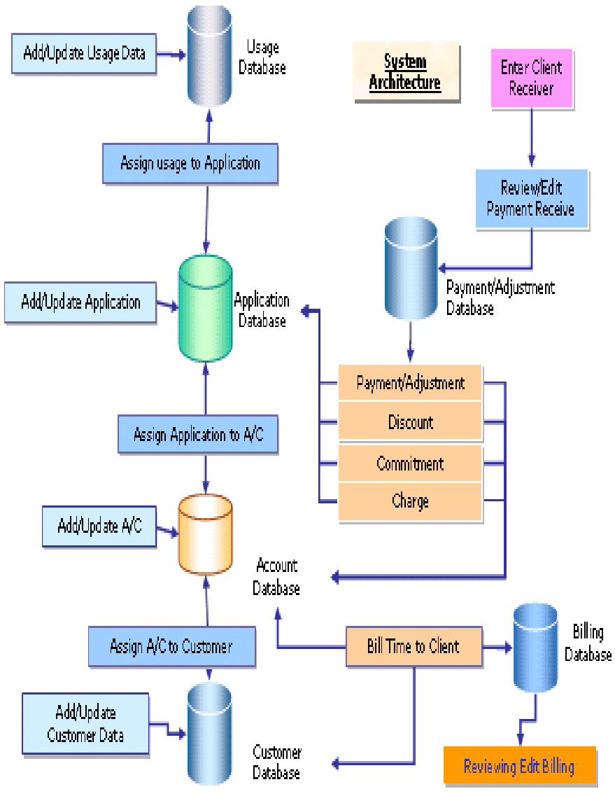

1. **Flow Chart.**

This diagram shows the flow of user activity within the application. From login till the purchase of an item and view of package delivery. The conclusion of this is the Logout.

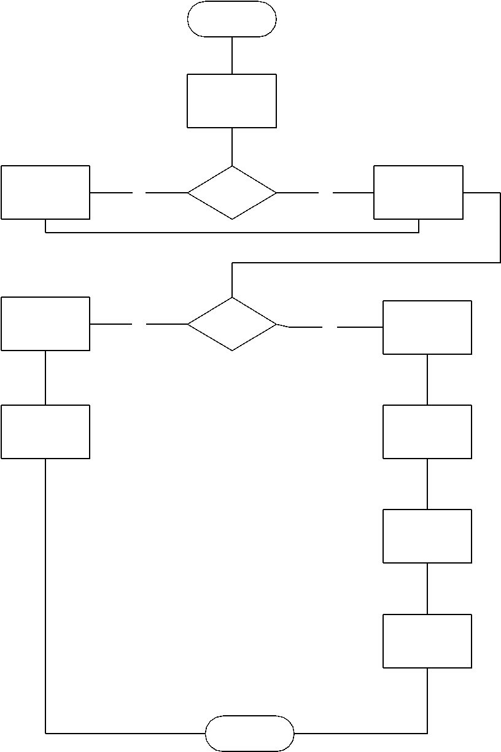

1. **Use Cases.**

This diagram shows the various activities that are available to the different users. The User will be able to sign-in, select and order and manage it. The Administrator would be able to view the delivery and the user activity.

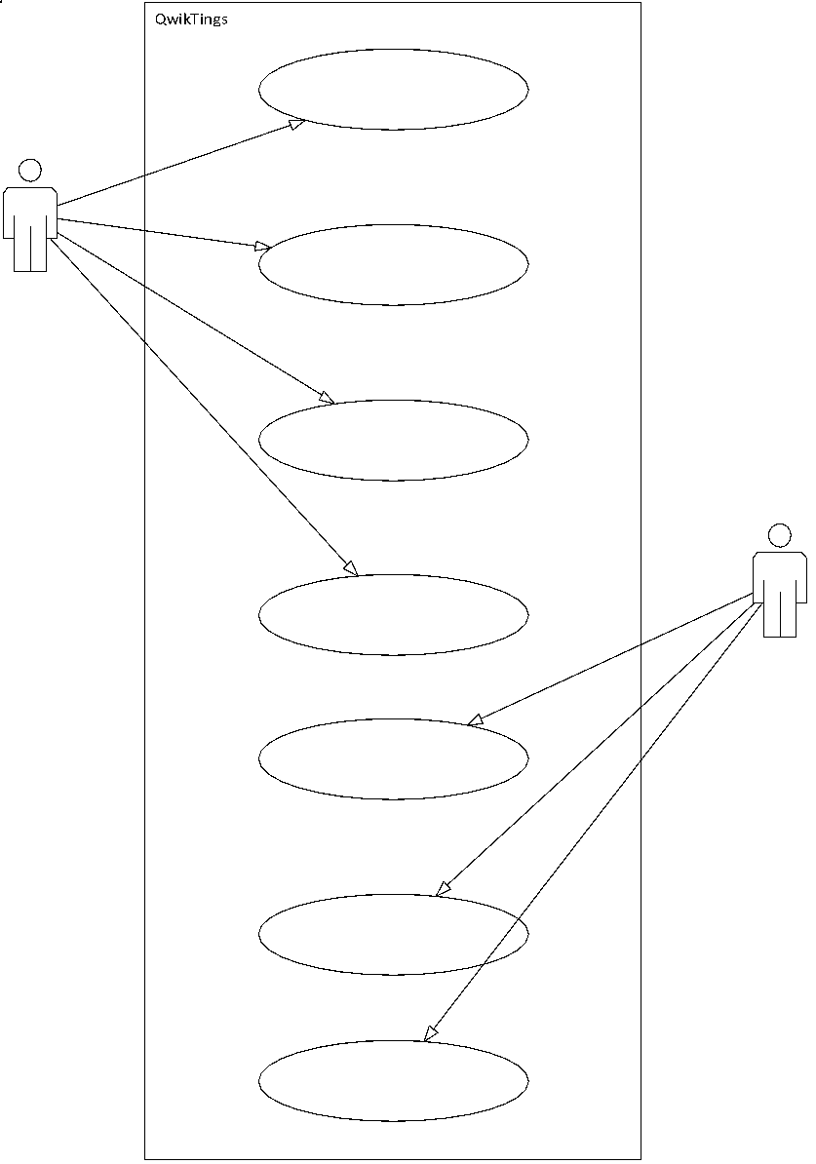

1. **Data Flow Diagram.**

This diagram represents the flow of data between the various activities within the application. The activities represent the various processes that are available within the QwikTings application.

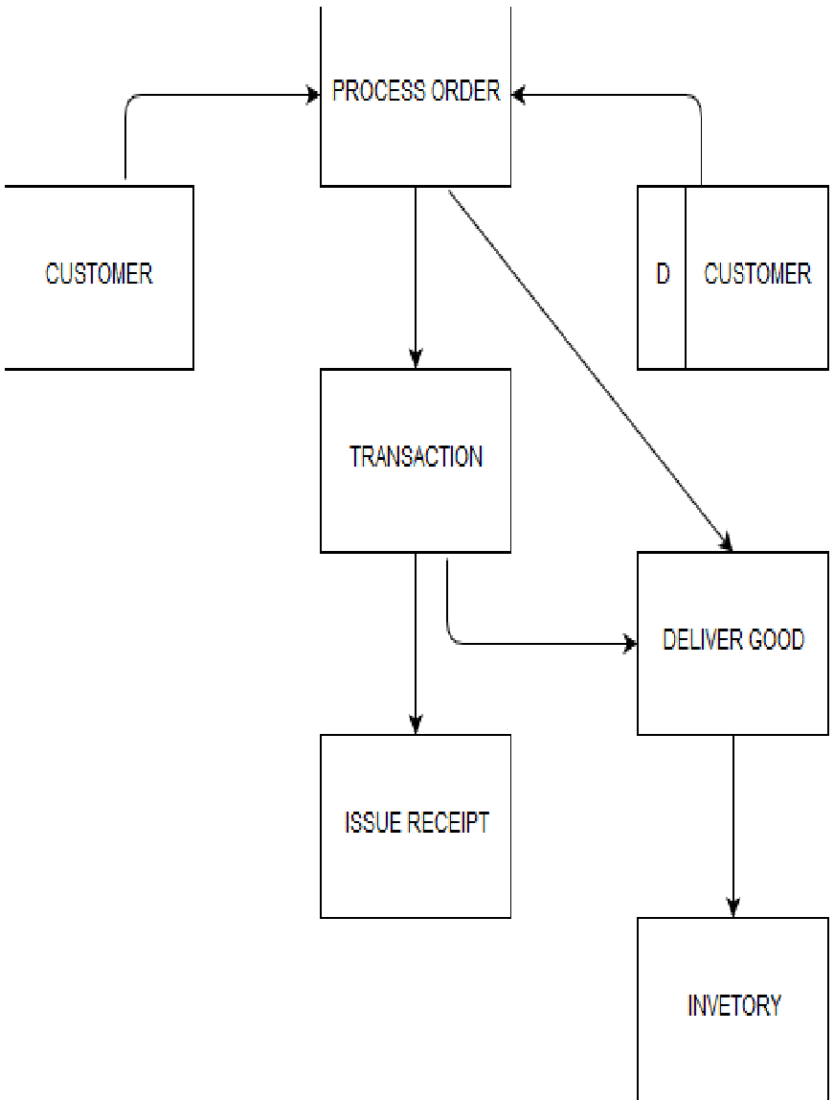

1. **Entity Relationship Diagram.**

This diagram shows how the various entities in the application database relate with each other. Each entity has a unique identifier so as to manage each transaction details individually and reduce confusion between relation of orders and the respective user.

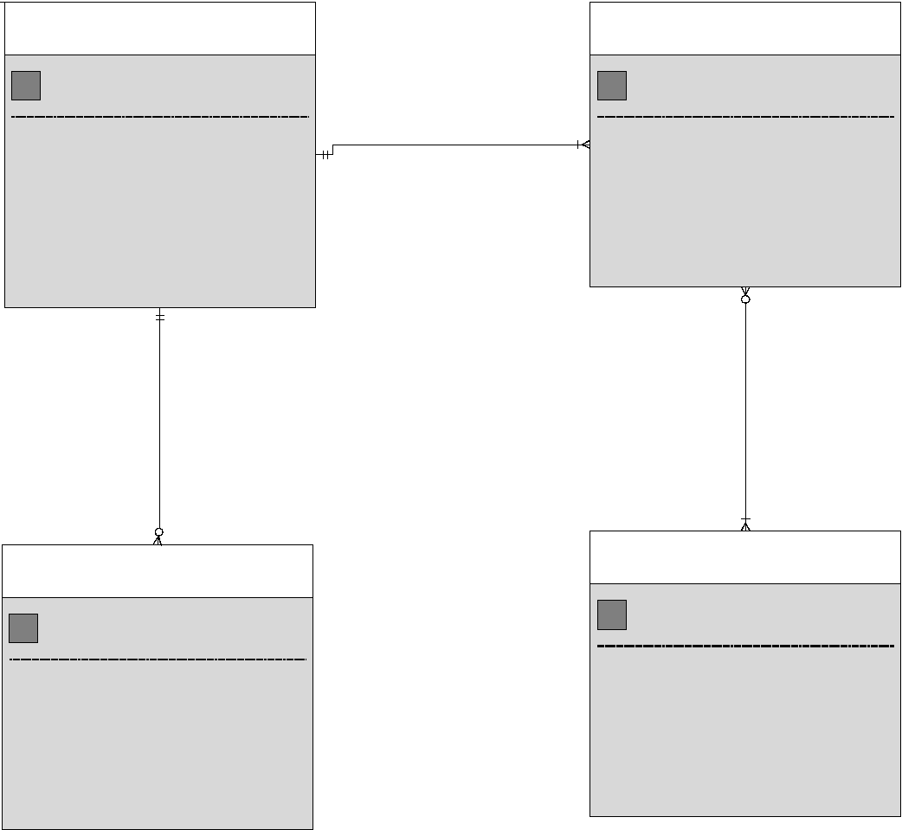

1. **Sequence Diagram.**

This diagram shows the flow of activities for the user within the QwikTings application. It is in order from the moment a user makes a purchase till the moment the user receives the purchase.

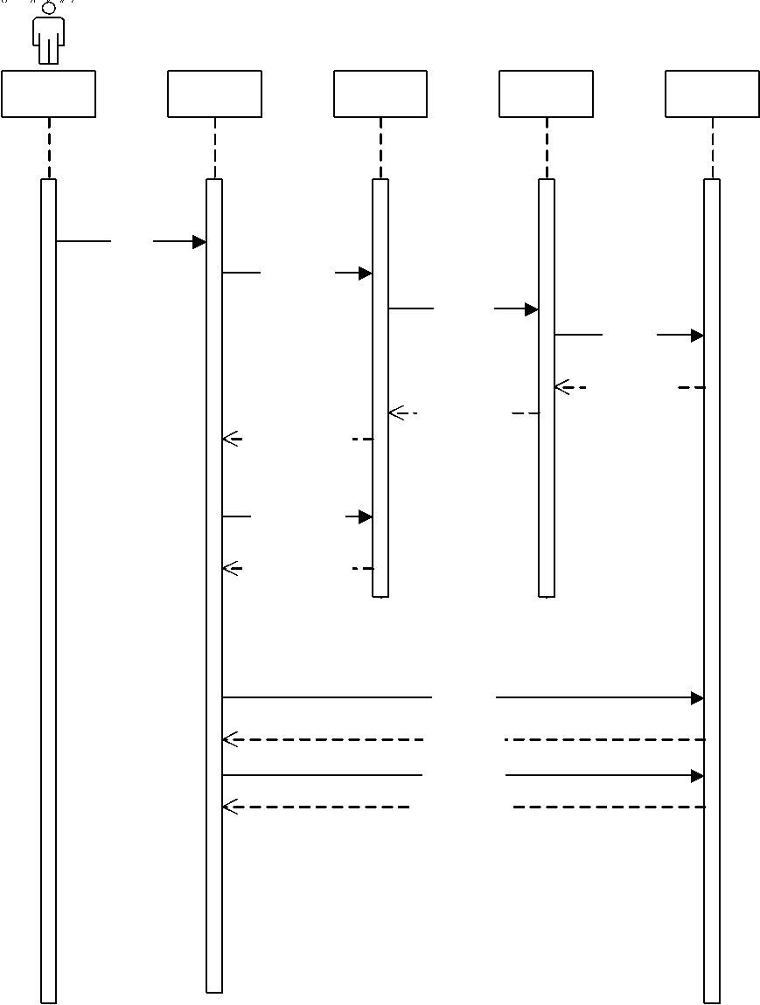

1. **Conclusion.**

In this chapter, we discussed all the design documents that were implemented in the QwikTings application. These were the design documents used as the blueprint entering into the development stage.

1. **IMPLEMENTATION & DEVELOPMENT.**

In this chapter, we shall discuss the actual development and coding of the application QwikTings. The development can be split into back-end development (server-side) and front-end development (client-side).

1. **Administrator.**

This talks about the development and implementation of the Administrator portal, or the server-side development. This is implemented by using Google Firebase to develop the application database, handle user login/register and the application’s notification system.

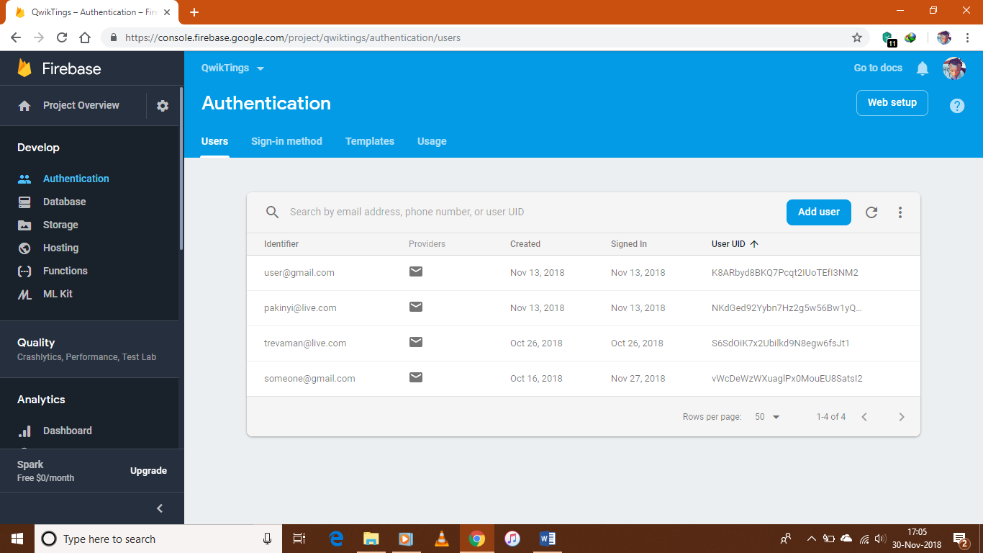

* + This diagram shows the current users of the QwikTings application.

The following diagrams show the design for the QwikTings application database.

* + This controls the menu items.

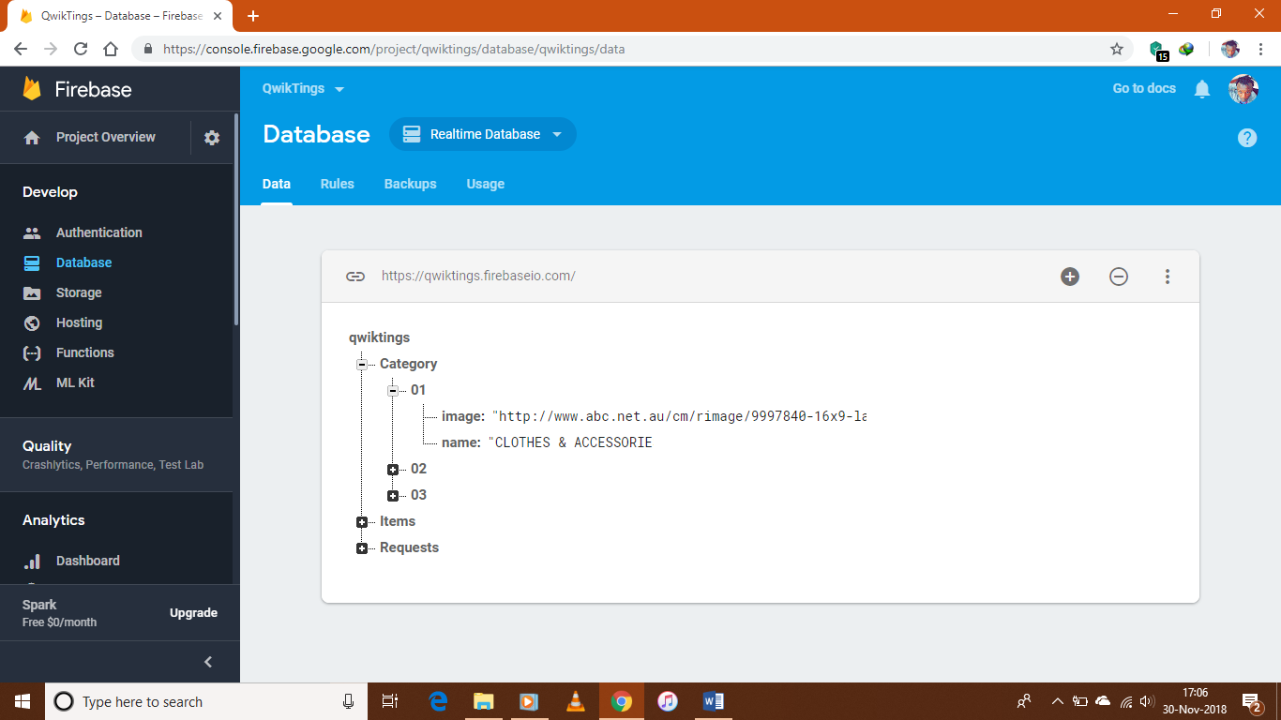

* + This controls the actual clickable items within the QwikShop which are offered on the QwikTings application.

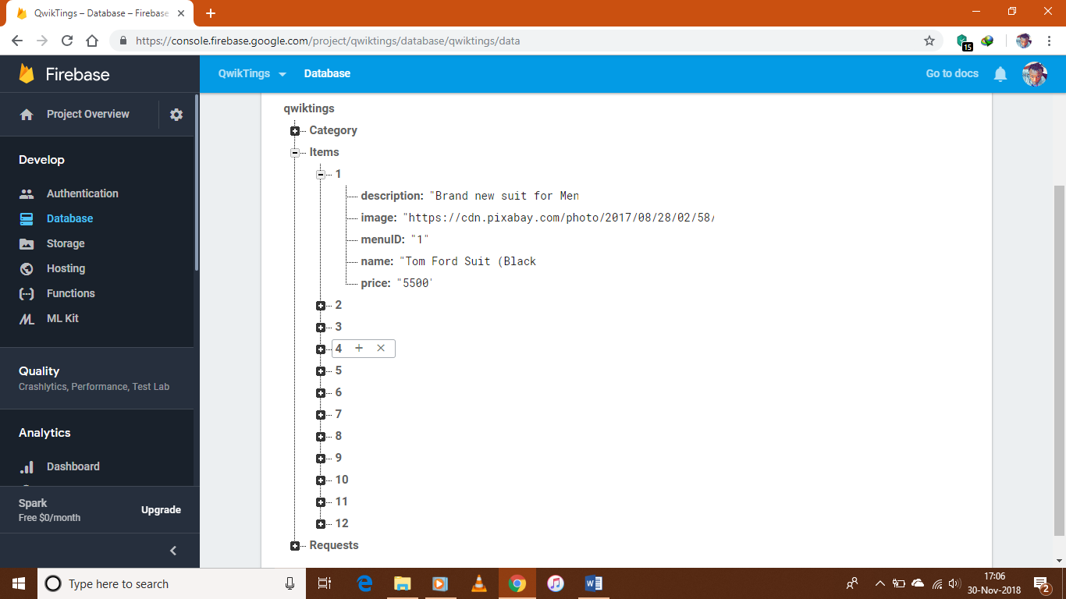

* + This is where the user requests were stored. Each request has a unique identifier in order to process each order individually.

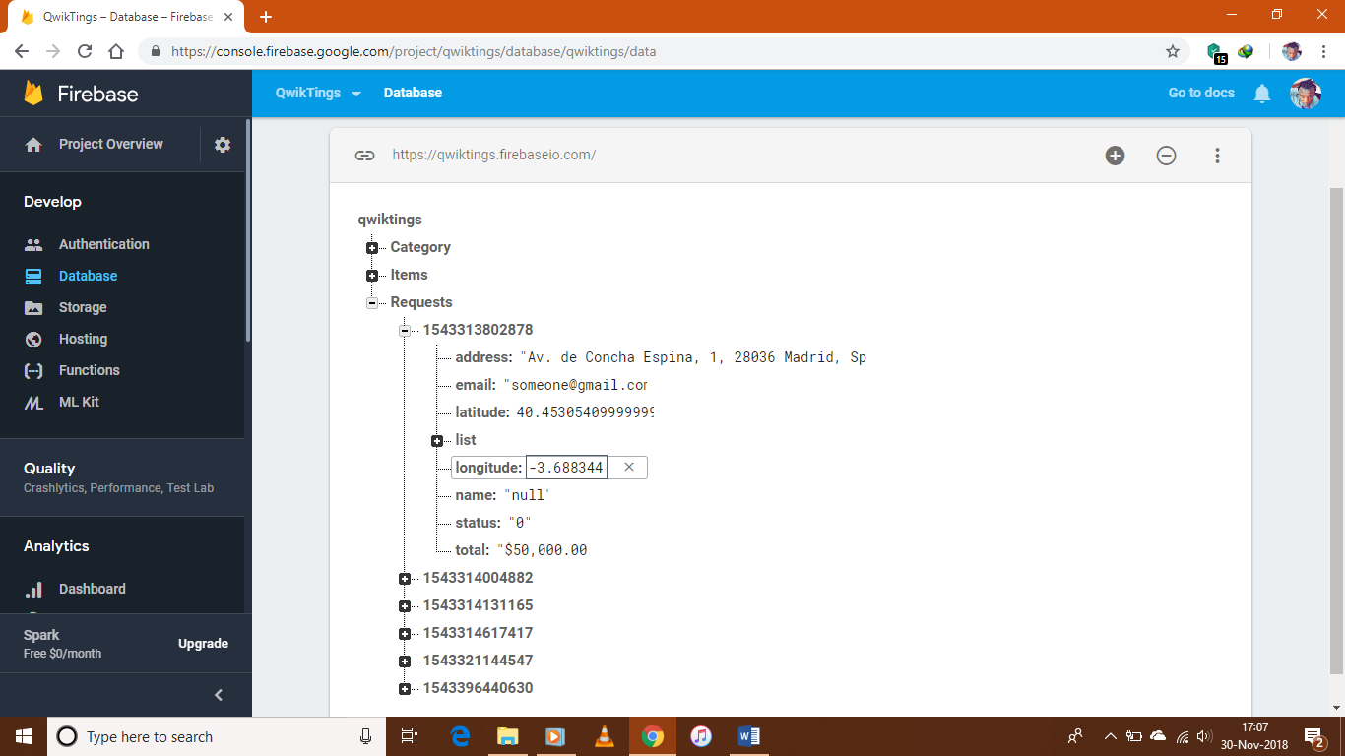

* + This shows the rules that define the database.

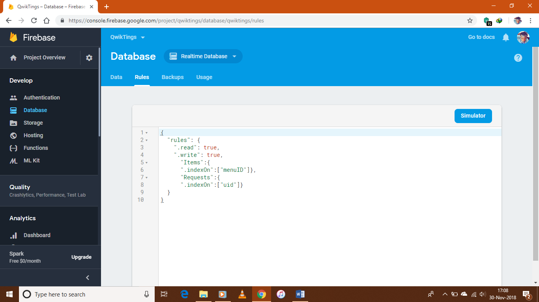

1. **User.**

This concerns the development and implementation of the User view of the application or the Client-Side.

* + The user can login, register and retrieve a lost password using these interfaces. The service is controlled using Google Firebase Authentication.

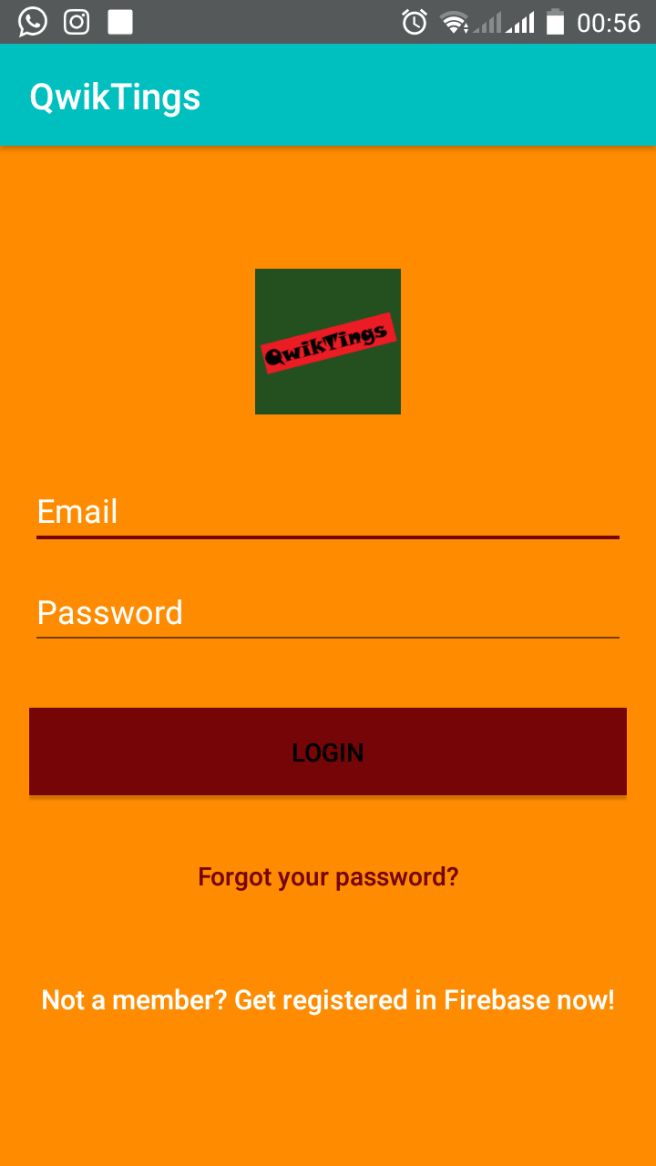

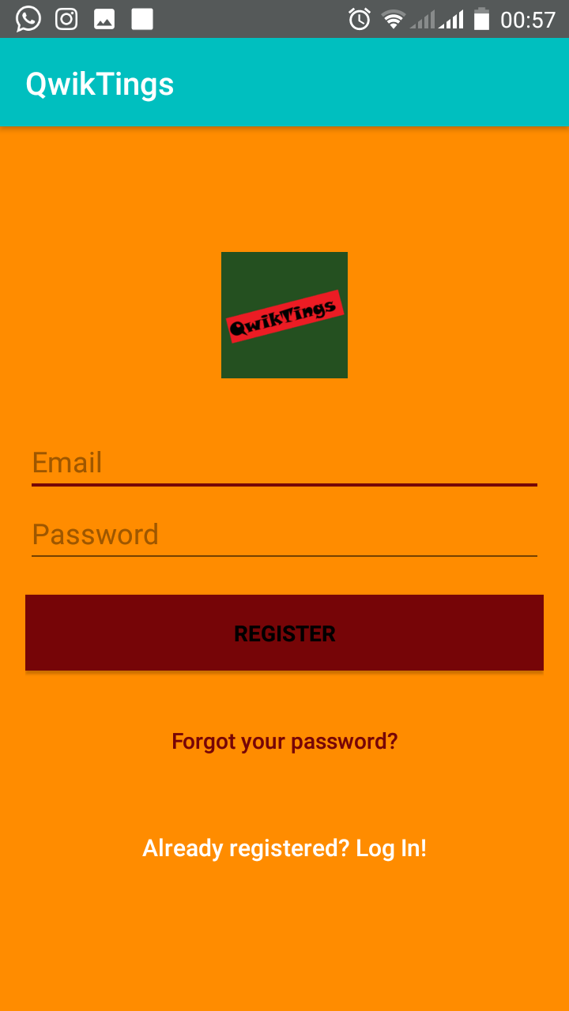

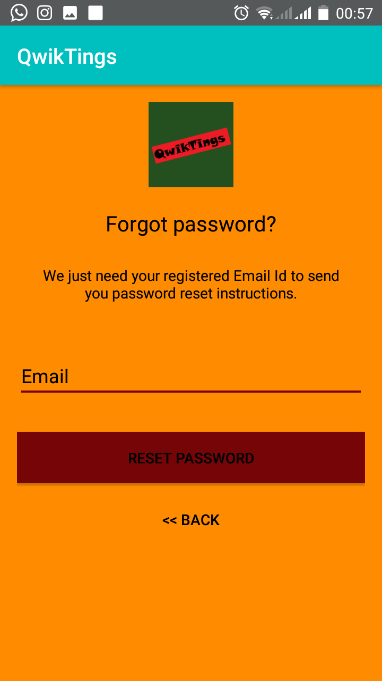

* + The user will then enter the home interface.

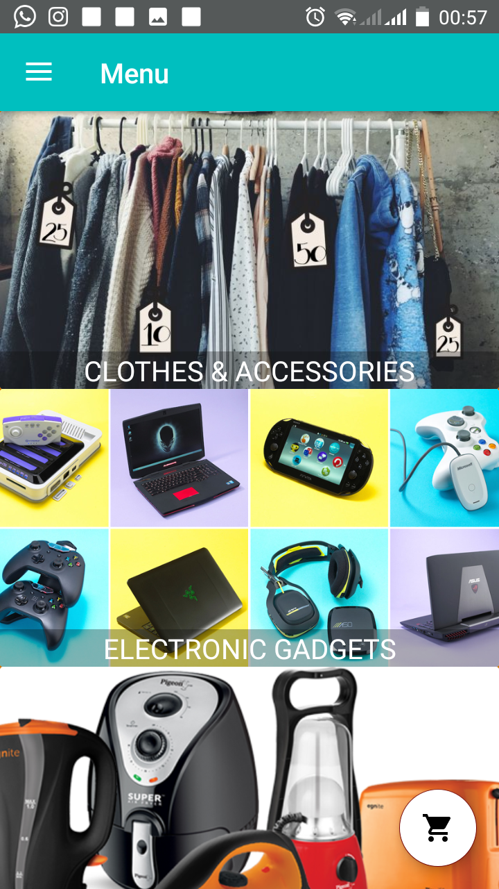

* + By tapping the home interface, the user can enter the menu of items.



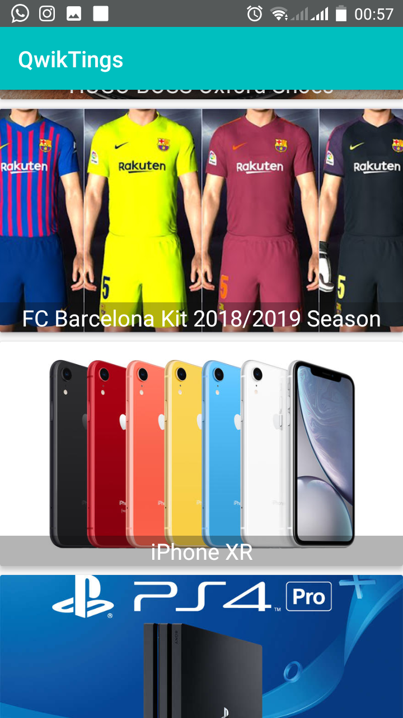

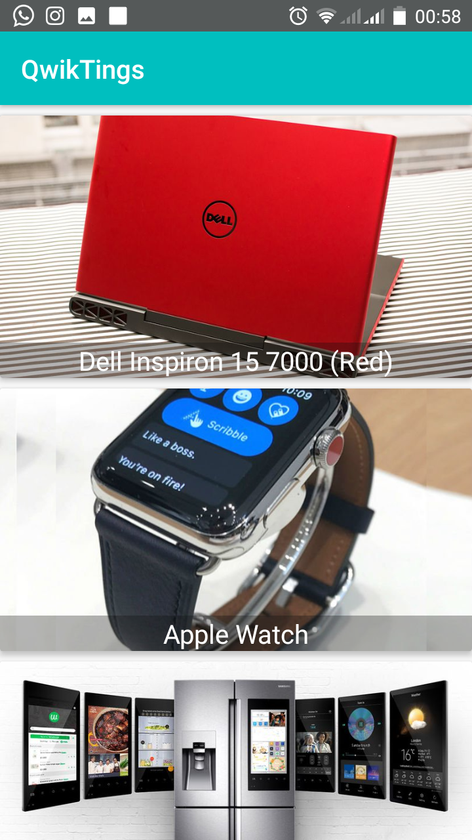

* + The user can select an item in the menu to get a more detailed description of the item and add the desired number of that particular item in view to the cart.

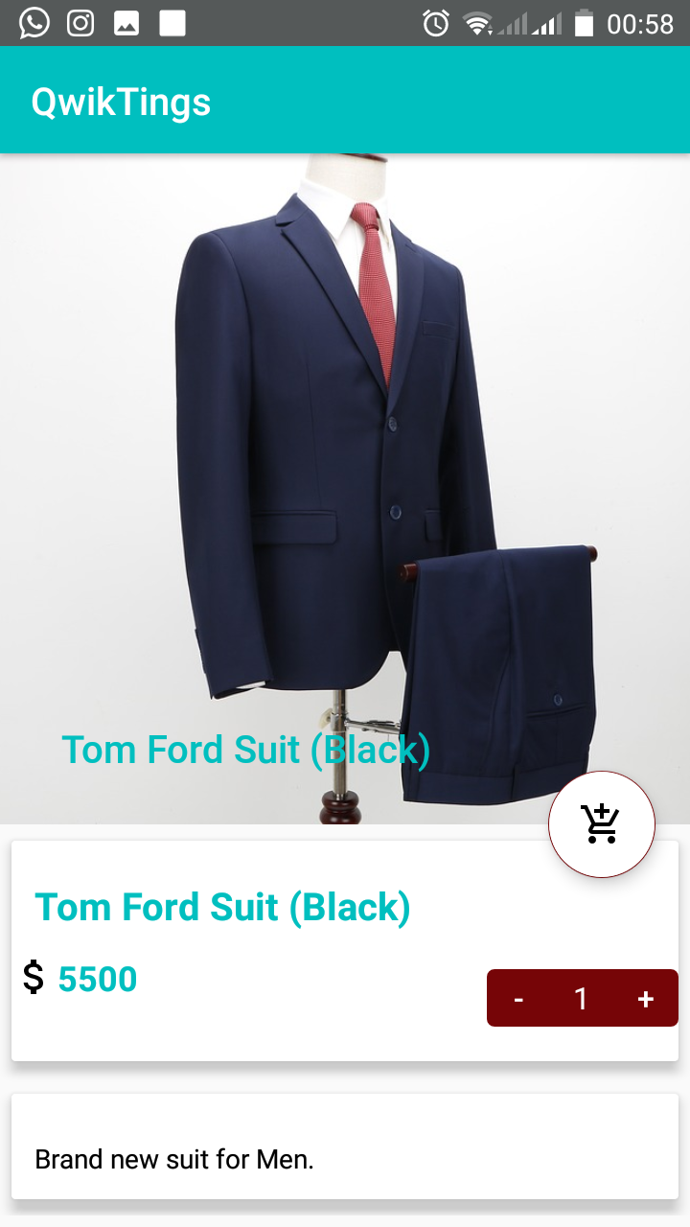

* + The user can view the items in their cart and confirm the order.

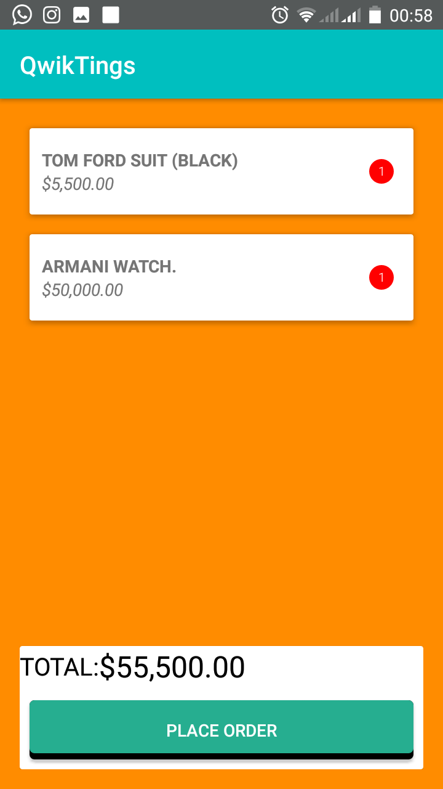

* + Once the user presses “PLACE ORDER”, the user is then prompted to select a destination to deliver the package to.

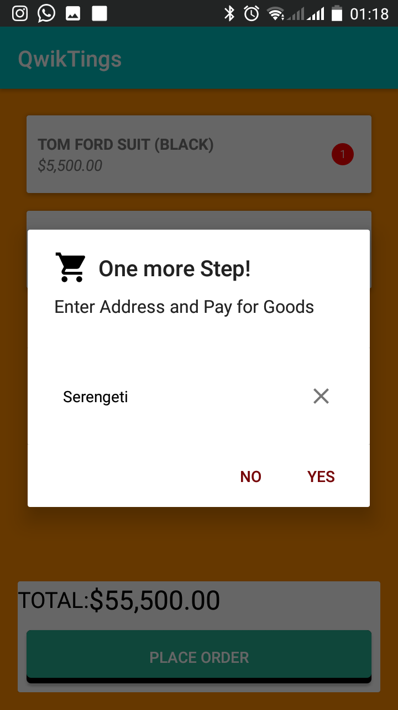

* + The user will then be prompted to a pay screen after inputting to pay for goods. The payment is done through integrating the MPesa API.

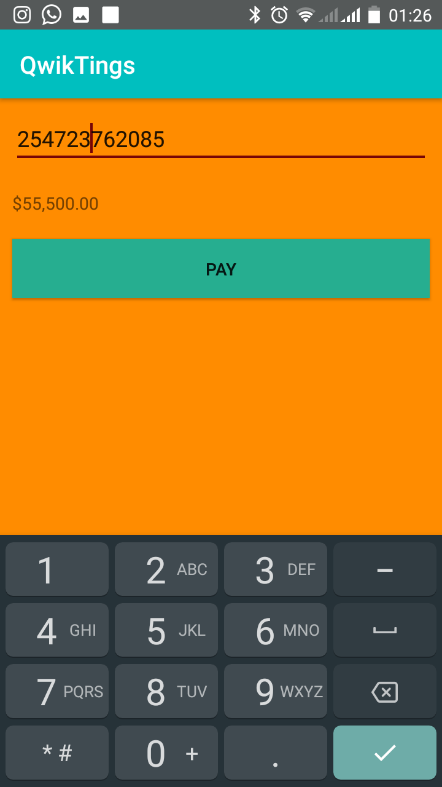

* + The user can then navigate around the application using the navigation tab.

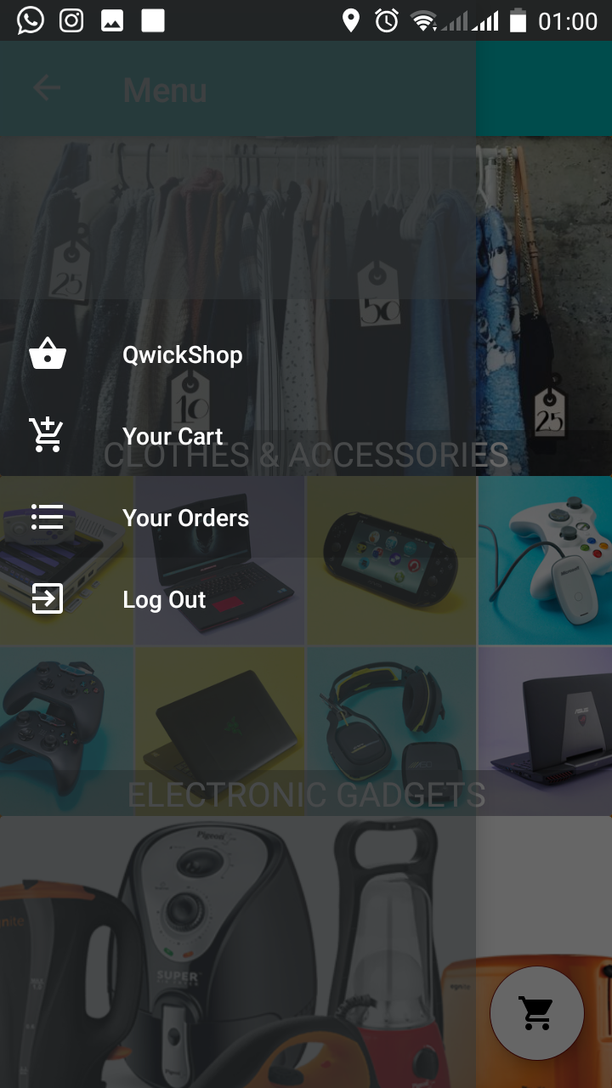

* + The user can also view the orders previously placed from “Your Orders” off the navigation bar.

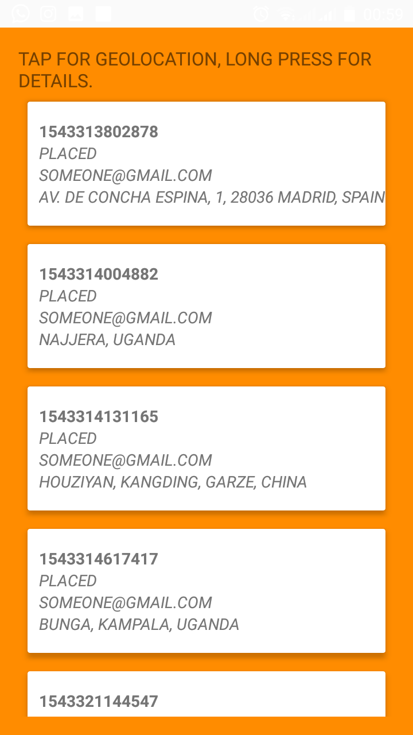

* + If the user taps on any of the items, a google map activity is brought up and the user’s location is automatically tagged on the world map.

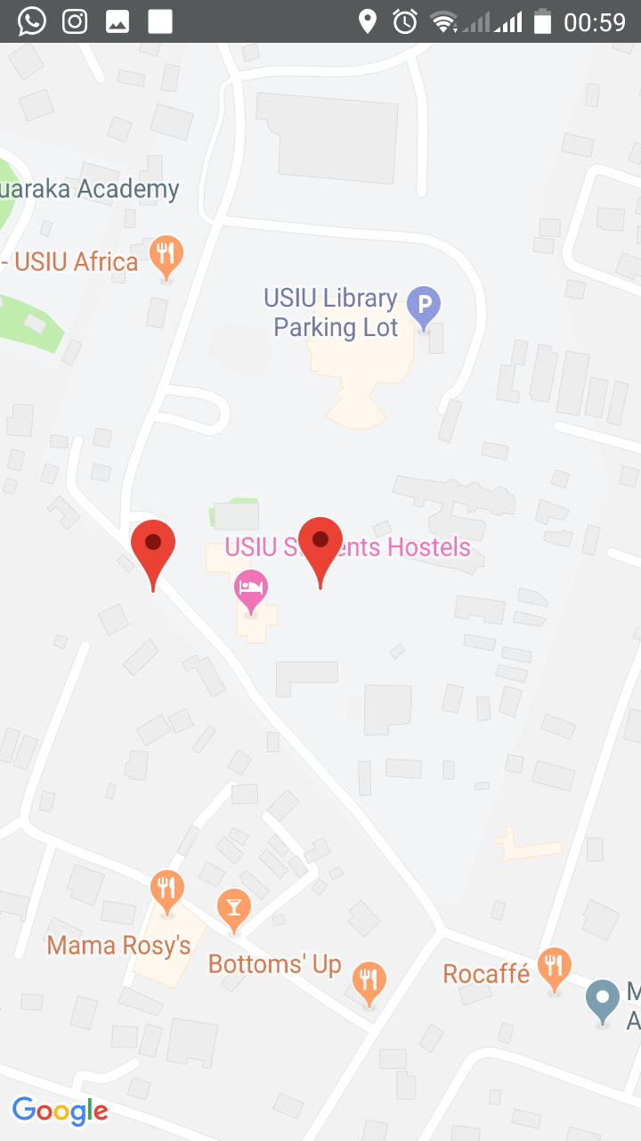

* + If the user long-presses one of the items off the “Your Orders” list, the user would then see in details the contents of that order.

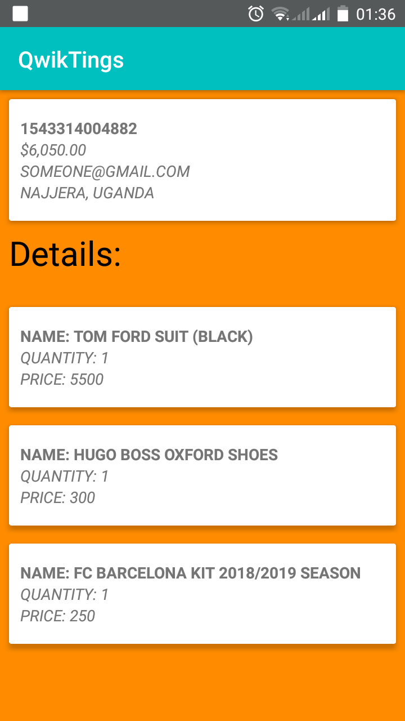

* + The user can also receive notifications about the status of their orders.

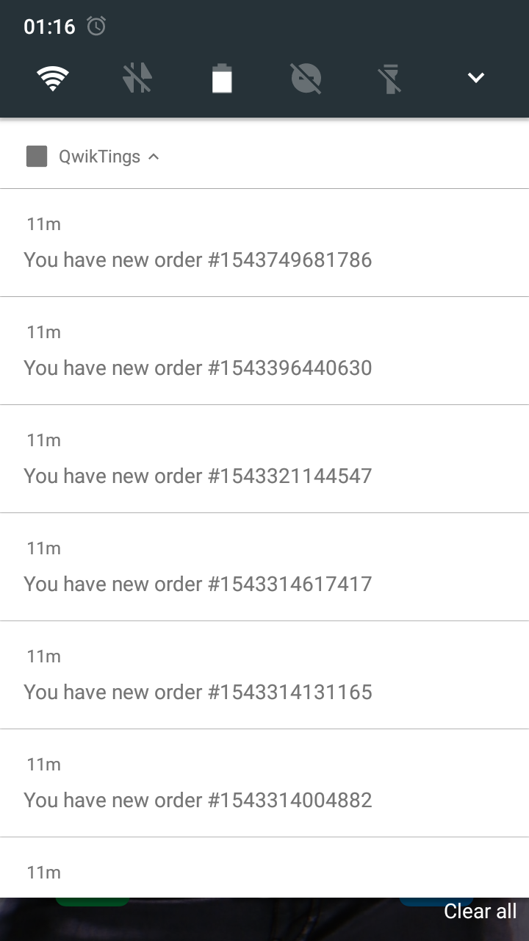

1. **Conclusion.**

In this chapter, we discussed the various roles and functions available to both the QwikTings administrator, and the QwikTings user.

1. **EVALUATION.**

The QwikTings application went through a series of tests before it could be brought out of production. Testing is a very vital element of the development as the application is pitted against the objectives earlier mentioned in this document and an evaluation is made.

1. **Types of Tests.**

Some of the tests that the application was put through include:

1. **Functional Testing**: Functional testing ensures that the application is working as per the requirements. Most of the test conducted for this is driven by the user interface and call flow.
2. **Laboratory Testing**: Laboratory testing, usually carried out by network carriers, is done by simulating the complete wireless network. This test is performed to find out any glitches when a mobile application uses voice and/or data connection to perform some functions.
3. **Performance Testing**: This testing process is undertaken to check the performance and behaviour of the application under certain conditions such as low battery, bad network coverage, low available memory, simultaneous access to application’s server by several users and other conditions. Performance of an application can be affected from two sides: application’s server side and client’s side. Performance testing is carried out to check both.
4. **Memory Leakage Testing**: Memory leakage happens when a computer program or application is unable to manage the memory it is allocated resulting in poor performance of the application and the overall slowdown of the system. As mobile devices have significant constraints of available memory, memory leakage testing is crucial for the proper functioning of an application.
5. **Interrupt Testing**: An application while functioning may face several interruptions like incoming calls or network coverage outage and recovery. The different types of interruptions are:

* Incoming and Outgoing SMS and MMS
* Incoming and Outgoing calls
* Incoming Notifications
* Battery Removal
* Cable Insertion and Removal for data transfer
* Network outage and recovery
* Media Player on/off
* Device Power cycle

An application should be able to handle these interruptions by going into a suspended state and resuming afterwards.

1. **Usability testing**: Usability testing is carried out to verify if the application is achieving its goals and getting a favourable response from users. This is important as the usability of an application is its key to commercial success (it is nothing but user friendliness). Another important part of usability testing is to make sure that the user experience is uniform across all devices. This section of testing hopes to address the key challenges of the variety of mobile devices and the diversity in mobile platforms/OS, which is also called device fragmentation. One key portion of this type of usability testing is to be sure that there are no major errors in the functionality, placement, or sizing of the user interface on different devices.
2. **Installation testing**: Certain mobile applications come pre-installed on the device whereas others have to be installed from the store. Installation testing verifies that the installation process goes smoothly without the user having to face any difficulty. This testing process covers installation, updating and uninstalling of an application**.**
3. **Security Testing**: To check for vulnerabilities to hacking, authentication and authorization policies, data security, session management and other security standards.
4. **Location Testing**: Connectivity changes with network and location, but you can't mimic those fluctuating conditions in a lab. Only in Country non automated testers can perform comprehensive usability and functionality testing.
5. **Load Testing**: When many users all attempt to download, load, and use your app or game simultaneously, slow load times or crashes can occur causing many customers to abandon your app, game, or website. In-country human testing done manually is the most effective way to test load**.**
6. **Black box Testing**: This type of testing doesn't include the internally coding logic of the application. Tester tests the application with functionality without peering with internally structure of the application. This method of test can be applied virtually to every level of software testing: unit, integration, system and acceptance.
7. **Crowdsourced Testing**: In recent years, crowdsourced testing has become popular as companies can test mobile applications faster and cheaper using a global community of testers. Due to growing diversity of devices and operating systems as well as localization needs, it is difficult to comprehensively test mobile applications with small in-house testing teams. A global community of testers provides easy access to different devices and platforms. A globally distributed team can also test it in multiple locations and under different network conditions. Finally, localization issues can be tested by hiring testers in required geographies. Since real users using real devices test the application, it is more likely to find issues faced by users under real world conditions (Wikipedia, 2018).

1. **Challenges.**

The process of developing the application was obviously not without challenges. The biggest one was integrating the Google Maps Application Programming Interface (API) with the QwikTings application.

The design had initially intended the maps activity to show a route and time estimate between the user’s current location and their package, however due to complexity and limited time, I was unable to add this aspect to the application.

1. **Conclusion.**

In this chapter, we discussed about what application testing is and the various application tests that QwikTings underwent. We also discuss about the challenged faced during the development of the application.

1. **CONCLUSION AND FUTURE WORK.**

This documentation contains the written description of how the mobile e-commerce application QwikTings works. The first chapter was introducing the idea of mobile applications and why mobile applications are gaining prevalence in Africa. The second chapter talks about the idea of the mobile application QwikTings and how it would pit up against the apps that are already in existence. Chapter three covered the aims and objectives that QwikTings was trying to achieve, and what would be necessary to achieve them. It also describes the methodology that was used during the development of the application. Chapter four handles the design documents for the application QwikTings and how they would be the blueprint for building the application components. Chapter five talks about the various stakeholders in the application QwikTings and how each of the respective functions for each stakeholder would operate. Chapter six discusses the various tests that the application underwent and the challenges that I faced as the developer.

1. **Future Work.**

There are certain aspects of this application that I would like to improve upon and add to with time. One of these would be to correct the maps activity so as it works as I intended it to and not as explained within my challenges.

I would like to add the ability to remember the user’s passwords and frequently accessed locations, so as to give a more personalised experience.

I would also like to integrate another payment method other than MPesa. Preferably PayPal or MasterCard in order to also capture the market that pays with credit and/or debit cards.

Lastly I would like to implement the use of QR codes for extra security as stated within my proposal letter.

**References**

Dahir, A. L. (2016, August 3). *Smartphone use has doubled in Africa in two years*. Retrieved November 28, 2018, from QuartzAfrica: https://qz.com/africa/748354/smartphone-use-has-more-than-doubled-in-africa-in-two-years/

Sharma, L. (2016, April 17). *WaterFall Model*. Retrieved November 30, 2018, from ToolSQA: http://toolsqa.com/software-testing/waterfall-model/

Wikipedia. (2018, September 5). *Mobile application testing*. Retrieved December 3, 2018, from Wikipedia: https://en.wikipedia.org/wiki/Mobile_application_testing

**APPENDIX I: PROPOSAL LETTER.**

**ABSTRACT.**

Advance Innovations Inc. proposes the application “QwikTings”. The proposed application is a mobile application that gives the user the ability to safely transport items bought on various online shopping platforms to a location of their preference. This is important because most online shopping platforms have very limited and poor delivery systems to and within Africa, and the proposed application would offer a solution to that. The service offered by QwikTings is that the user would be able to safely transport multiple online purchases simultaneously in real time. The first stage of the project is to research the viability of using android to develop this application and the possibility of tracking items in real time. Barcode readers would be handheld and operated by all members of staff within Advance Innovations Inc. whereas RFID tags would be on crates or pallets with the gateway being at the warehouse to track items going in and out. The second stage is to critically analyse all solutions but pick the best and the financial viability then implement the solution and create a prototype.

**INTRODUCTION.**

The proposed system will give Advance Innovations Inc. an easier way to track the movement of their client’s packages. The system would track crates or pallets of shipments using RFID tags and use barcode readers to track the package delivery by staff and/or associated parties to the user’s location.

The first part of the project will be about research on the capability of android to implement real time tracking and exciting user interfaces as well as its integration into popular online shopping platforms such as Amazon & eBay.  Another possible solution for Advance Innovations Inc. would be QR (Quick Response) codes. These are a matrix / two-dimensional bar code that require an internet connection.

Once the plausibility of the above mentioned concepts within the language has been properly assessed, the system can be designed and implemented to work within the mobile application.

**BACKGROUND.**

Advance Innovations Inc. is a start-up Tech Company that deals in various software applications and tech-oriented solutions. The project will focus solely on the QwikTings application, but they do offer a wide variety of solutions.

Advance Innovations chose to focus on the shipment of packages as a service offered through a mobile application due to the unavailability of shipping services to and within Africa. QwikTings aims to target that particular market and develop a product that is tech-oriented and provides the best possible service. Advance Innovation intends to make use of RFID tags and Barcodes to track the movements of shipments and delivery by their staff. The application also intends to use QR codes to verify ownership of packages among the users. This product also aims to be highly secure and efficient so as the user can have the least hassle while using the application.

**PROPOSED PROJECT.**

The aim of the project is to research into android’s ability to be integrated with online shops APIs e.g. Amazon as well as QR Codes and then come up with the best solution for Advance Innovations Inc. for shipping and tracking the packages of their clients efficiently and securely. QR codes are the preferred option and are good as they are made for high speed decoding, they may also work well with the mobile application as users would be able to manage their items via the QR code.

Once the research phase has been completed a meeting with Advance Innovations shall decide on the best course of action and shall have to decide upon which proposed method is best for their business due to the features it offers as well as the cost being acceptable. This will consist of which APIs to include in the project.

When presenting the project to our investors Advance Innovations will have to come with a working prototype to best illustrate how the application works.

We may have to alter or complete work on the mobile application as the current mobile application is not fully complete, this said most of the features are working. One of the main issues is that this is a very costly project and would involve massive resources to start and implement. Another issue would be that the project would require a vast network which is not always easy to handle.

**PROGRAM OF WORK.**

The main phases of the project work can be broken down into:

1. ***Research ideas in Android* –** This involves doing research into Android and QR codes.
2. ***Analyse research* –** Comparing all the options benefits and weaknesses but also considering cost to decide on the best option for Advance Innovations Inc.
3. ***Present proposed system* –** Present the proposed best solution to investors with an initial prototype.
4. ***Design system* –** Design the proposed system once it has been agreed with the investors, make any changes to mobile application and write code to make QR work with mobile application.
5. ***Implementation* –** Integrate software / devices with the mobile application.
6. ***Testing* –** Thoroughly test the mobile application to evaluate the system and allow chance to remove any bugs. Carry out trial tests.
7. ***Finish software & create* instructions –** Create the final software and

write instructions on how to use the system.

1. ***Finish Report***

**GANTT CHART.**

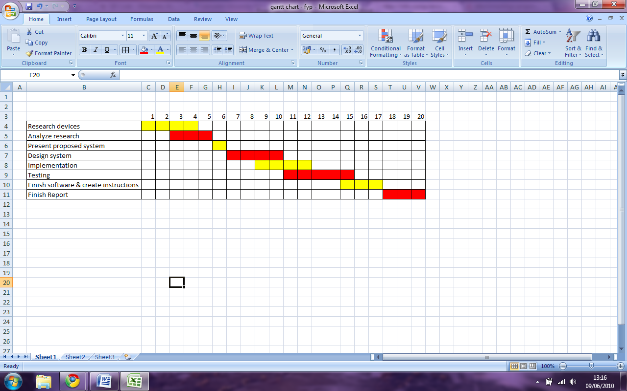

**RESOURES REQUIRED.**

* Android Studio.
* GSM 3G Enabled Android Phone with QR-Capable Camera.
* Database Server.
* Payment APIs.

**APPENDIX II: QwikTings API.**

Please access the QwikTings API at either of these links:

Link 1: <https://1drv.ms/u/s!ArPOZMclVfAJi3vleW64RMvjH64a>

Link 2: <https://github.com/MrKintu/QwikTings>